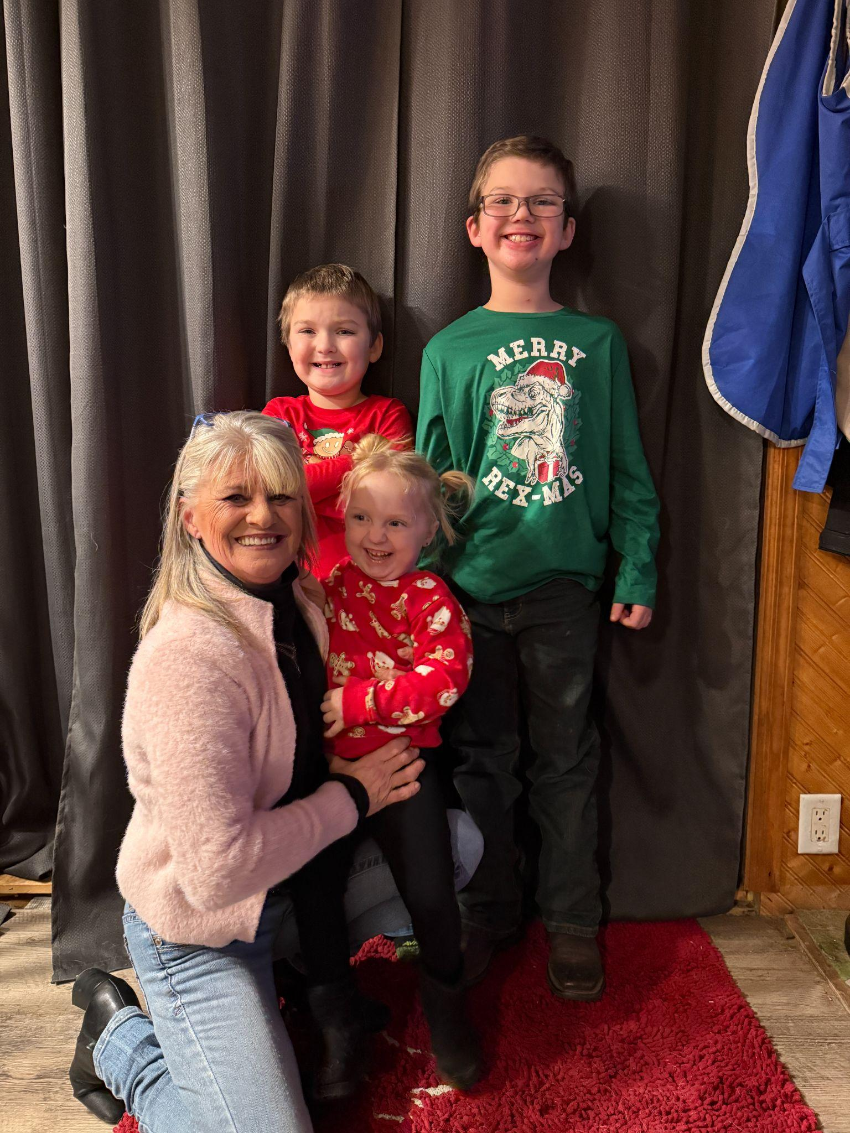

Patricia Knudson
CLTS Mentor
PROFESSIONAL PROFILE:
Patricia Knudson is a compassionate and dedicated CLTS Mentor who brings profound empathy and authentic understanding to her work with children and adults facing complex challenges. Her expertise encompasses supporting individuals with autism, ADHD, addiction, and various mental health conditions, drawing from both professional training and deeply personal lived experience.
LIVED EXPERIENCE & EXPERTISE:
Patricia's journey began in a home affected by addiction, leading to her placement in foster care during her formative years. Rather than allowing these early challenges to define her limitations, Patricia transformed her experiences into powerful tools for healing and advocacy. This background provides her with genuine insight into trauma, family dysfunction, and the resilience required for recovery, enabling her to connect authentically with clients who face similar struggles.
Her personal history of overcoming adversity has shaped her into a resilient advocate who understands the complexities of healing from a place of genuine experience rather than theoretical knowledge alone.
FAMILY & COMMUNITY FOUNDATION:
Now thriving in Eau Claire, Patricia has built a fulfilling family life centered around her adult son and his loyal companion dog. As a proud mother of two wonderful children and devoted grandmother to three grandchildren—two boys and one girl—she embodies the healing and growth possible through dedicated support and love.
Patricia serves as both a loving grandmother and vital support system for her grandsons, providing respite care and nurturing guidance that demonstrates her commitment to breaking cycles and creating positive family legacies. Her dual role as family caregiver and professional peer specialist enriches her understanding of the challenges families face and the support systems necessary for success.
THERAPEUTIC APPROACH:
Patricia's approach to peer support is grounded in hope, resilience, and an unwavering belief in every individual's potential for growth and healing. She creates safe, non-judgmental spaces where clients feel truly understood and supported in their journey toward wellness.
Her ability to connect across age groups—from children to adults—stems from her genuine care and the authentic relatability that comes from having navigated her own path to healing and stability.
PERSONAL INTERESTS & BALANCE:
Outside of her professional commitments, Patricia finds renewal and joy spending time by the water, cherishing meaningful moments with family, and fostering connections that enrich the lives of those around her. These activities reflect her belief in the importance of community, nature, and relationships as essential components of mental health and well-being.
SERVICES OFFERED:
• Individual peer support
• Trauma-informed care and recovery support
• Family system guidance and respite care
• Specialized support for autism and ADHD
• Addiction recovery peer mentoring
• Mental health advocacy and empowerment
Patricia's story exemplifies the transformative power of turning personal challenges into professional strengths, making her an invaluable resource for individuals and families seeking authentic, experience-based support on their journey toward healing and growth.

